
BIRKERØD GYMNASIUM,
HF, IB & KOSTSKOLE

IB DIPLOMA PROGRAMME

Mathematics Standard Level SL
Test 2 P1
Test on Common core material

December 2019

40 minutes

Instructions to candidates:
- Write down your name in the space provided.
- Do not open this examination paper until instructed to do so.
- A graphic display calculator is not allowed for this test
- Answer all the questions
- Write your answers in the spaces provided.
- You are advised to show all working, where possible. Where an answer is wrong, some marks may be given for correct method, provided this is shown by written working.
- Unless otherwise stated in the question, all numerical answers must be given exactly or rounded to 3 significant figures.

Points:_______________/40 Grade:

Name:______________________________________________________________________________________

Teacher: (AA, ARC or ANU) ______________________________________________________________

Question 1. [total marks: 8]
The final examination results obtained by a group of 3200 Biology students are summarized on the cumulative frequency graph.
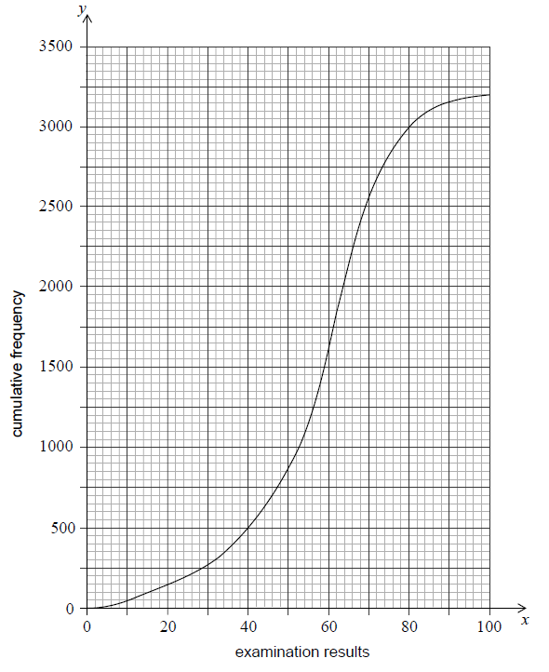
- Find the median of the examination results. [2 marks]
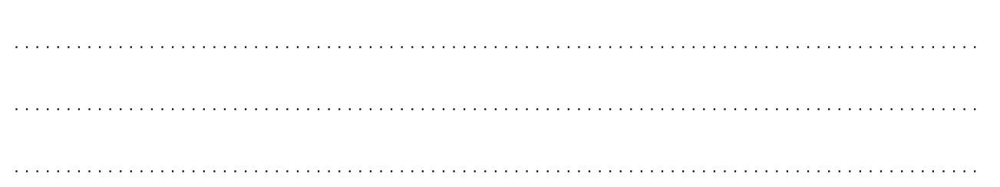

- Find the interquartile range. [3 marks]

- 350 of the group obtained the highest possible grade in the examination.
Find the final examination result required to obtain the highest possible grade. [3 marks]

Question 2. [total marks: 6]
- Place the numbers $2π, -5, 3^{-1}$ and ${(\sqrt{2})}^{3}$ in the correct position on the Venn diagram.
[4 marks]

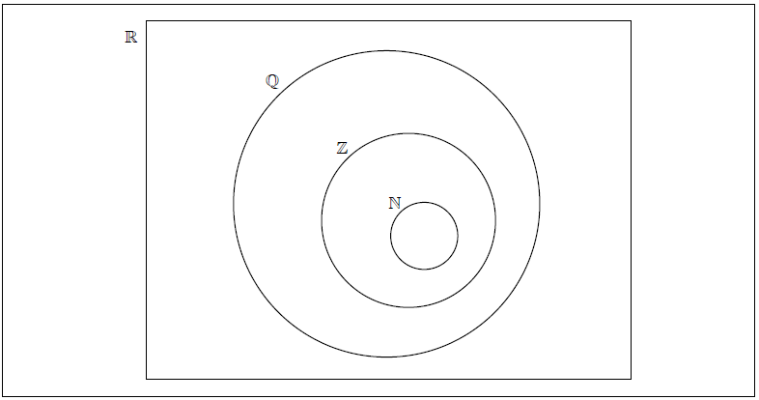

- In the table indicate which two of the given statements are true by placing a tick (✔) in the right hand column.
[2 marks]

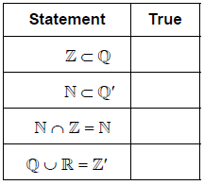

Question 3. [total marks: 15]
A group of 10 girls is to be sampled from all the girls in a school with 500 girls. The girls are selected for the sample from a list of all the 500 girls in a random order numbered from 1 to 500 by a systematic sampling method, starting with the 13th girl.

(a) Write down the numbers of first 5 girls who are sampled. [2 marks]

The group of 10 girls recorded the number of hours they spent watching television during a particular week. Their results are summarized in the box-and-whisker plot below.

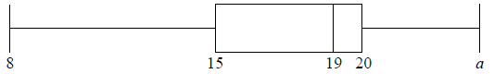

(b) The range of the data is 16. Find the value of a. [2 marks]

(c) Find the value of the interquartile range. [2 marks]

The group of girls watched a total of 180 hours of television.

(d) Find the mean number of hours that the girls in this group spent watching television that
week. [2 marks]

A group of 20 boys also recorded the number of hours they spent watching television that same week. Their results are summarized in the table below.
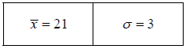
(e) Find the total number of hours the group of boys spent watching television that week.
[2 marks]

The following week, the group of boys had exams. During this exam week, the boys spent half as much time watching television compared to the previous week.

(f) For this exam week, find

(i) the mean number of hours that the group of boys spent watching television. [2 marks]

(ii) the variance in the number of hours the group of boys spent watching television. [3 marks]

Question 4. [total marks: 6]

Line L₁ passes through the points A(−3, 0.5) and B(9, −3.5).

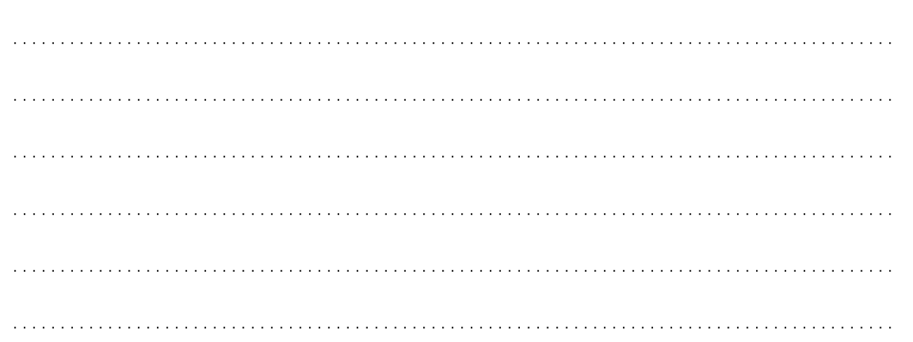
(a) Find the gradient of L₁. [2 marks]

Line L₂ passes through the point C(3, 1) and is parallel to L₁.

(b) Determine the equation of L₂. [2 marks]
Give your answer in the form $ax+by+d=0$, where a, b, and d are integers.

(c) Find the coordinates of the x-intercept of L₂. [2 marks]

Question 5. [total marks: 5]

In triangle ABC, sides AB = $\sqrt{72}$ and BC = 12. Angle CAB = 135$°$ .

You are given that $\sin{135°=\frac{1}{\sqrt{2}}}$ and that $\sin{30°=\frac{1}{2}}$.

Find angle ABC.

The diagram is NOT to scale
12
A
$$\sqrt{72}$$
135$°$

B

C

